Software Design Description

Version 1.0

October 07, 2013

Shopping Cart

Software Engineering Team

Bertram Bishop

David Anderson

Marin Rangelov

Hoang Nhan

# 

# Table of Contents

Table of Contents

Table of Contents ii

List of Figures iii

1.0. Introduction 1

1.1. Purpose 1

1.2. Scope 1

1.3. Overview of Document 1

1.4. References 1

1.5. Glossary 2

2.0. Use Case Realizations 3

3.0. Architectural Design 9

3.1. Class Diagram 9

4.0. Data Structure Design 10

4.1. Scheme Diagram 10

# List of Figures

Figure 1.0 ……………………………. Use Case Diagram

Figure 2.0 ……………………………. Create Store Use Case Narrative

Figure 2.1 ……………………………. Create List Use Case Narrative

Figure 2.2 ……………………………. Manage Store Use Case Narrative

Figure 2.3 ……………………………. Manage List Use Case Narrative

Figure 2.4 ……………………………. Search List Use Case Narrative

Figure 3.0 ……………………………. Class Diagram

Figure 4.0 ……………………………. Schema Diagram

# 1.0. Introduction

## 1.1. Purpose

The purpose of this document is to describe the architecture and system design of the Shopping Cart software described in the Shopping Cart Business Requirements Document. The intended audiences of this document are the Android developers, QA testers, and system owners that will collaboratively develop the system and possibly extend the system in the future. The Shopping Cart software is design to create and managed grocery shopping lists.

## 1.2. Scope

The document describes the design and implementation details of the Shopping Cart software. The major functions of the Shopping Cart software are to create and manage shopping lists/stores. The Shopping Cart software is to be developed for the Android platform using the object oriented design methodology.

1. Shoppers must access the Shopping Cart application from an Android device (Smart Phone, etc.)
2. The Shopping Cart application must be accessed by the shopper to create and manage shopping lists/stores.
3. The Shopping Cart application is a standalone application with no external interfaces.
4. All interfaces are managed by the Android system.
5. The Android system’s local database would be used to store all data saved by the Shopping Cart application.

## 1.3. Overview of Document

The Software Design Document is divided into five sections with subsections. The sections in this Software Design Document are:

1. **Introduction**
2. **Use Case Realizations**
3. **Architectural Design**
4. **Data Structure Design**

## 1.4 References

No references

## 

## 1.5 Glossary

**Android** – programming language

**Business Requirements Document** – a document that describes the requirements for a business process that must be delivered to provide value.

**Developers** – person who writes the code or develop the software

**Interfaces** – a piece of software\hardware that provide access to a system’s resources

**QA Tester** – software tester who ensures software quality

**Standalone Application –** an application that does not interact with any external interfaces.

**System** – software to be developed

**Systems Owner** – person(s) that owns the system

**Testers** – person(s) who perform the testing of the software to ensure quality of the end product

# 2.0 Use Case Realizations

The use case realizations are depicted by the use case diagram and the use case narratives.

**2.1. Actors**

**2.1.1 Shopper**

**2.1.1.1** Information: The Shopper is a user who uses the Shopping Cart application to simplify their shopping experience by creating grocery shopping lists, creating stores, associating lists to stores, associating items to categories/aisles, and saving the list/contents for current or future use.

**2.1.1 Use Case Diagram**

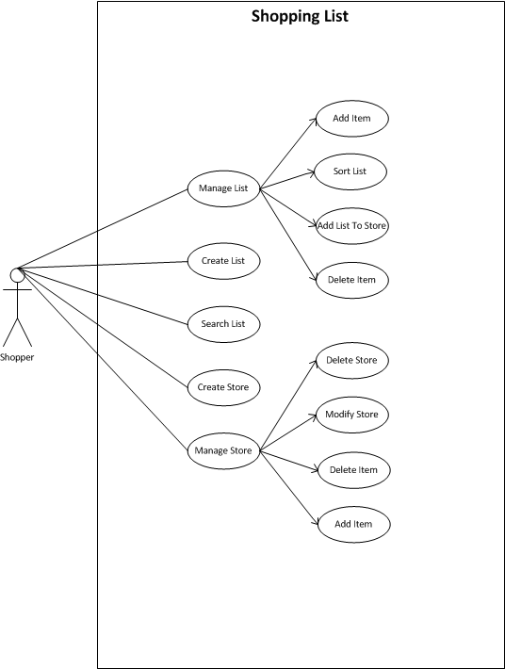

**Figure 1.0**

**2.2. Use Case Narratives**

**2.2.1 Create Store use case**

**Author (s): Bertram Bishop____________ Date: __09/26/2013_________**

**Version: ____1_______**

|  |  |  |  |
| --- | --- | --- | --- |
| **USE CASE NAME:** | Create Store | | **USE CASE TYPE** |
| **USE CASE ID:** | UC_1 | | Business Requirements: **🞏** |
| **PRIORITY:** | High | | System Analysis: **🗹** |
| **SOURCE:** | Shopping List Requirements Document | |  |
| **PRIMARY BUSINESS ACTOR** | Shopper | | |
| **PRIMARY SYSTEM ACTOR** | System | | |
| **OTHER PARTICIPATING ACTORS:** | NA | | |
| **OTHER INTERESTED STAKEHOLDERS:** | Android developers, QA testers, and system owners | | |
| **DESCRIPTION:** | This use case allows a shopper to create a store by typing in a grocery store name and saving the information. | | |
| **PRE-CONDITION:** | The shopper must launch the application | | |
| **TRIGGER:** | The use case starts when the shopper creates a store. | | |
| **TYPICAL COURSE** | **Actor Action** | **System Response** | |
|  | **Step 1:** The Shopper touches\click the Shopping List application icon. | **Step 2:** The system launches the application | |
|  | **Step 3:** The Shopper type store name into store name field, if store not found **go to step 4.** | **Step 4:** The Shopper creates a new store. | |
| **OF EVENTS:** | **Step 5:** The system updates store list with the new stores information when the shopper save the data. |  | |
|  |  |  | |
|  |  |  | |
| **ALTERNATE COURSES:** | **Step 4:** The system would notify the Shopper if a duplicate store if found and will not update the store list. | | |
| **CONCLUSION:** | The use case concludes when the Shopper manages store by creating item list (adding item and deletes item), modify store (update name and/or address), and delete store. | | |
| **POST-CONDITION:** |  | | |
| **BUSINESS RULES** |  | | |
| **IMPLEMENTATION CONSTRAINTS AND SPECIFICATIONS** | * Shoppers must use an Android tablet or smart phone. | | |
| **ASSUMPTIONS:** | * Users have a device built on the Android platform | | |
| **OPEN ISSUES:** |  | | |

**Figure 2.0**

**2.2.2 Create List use case**

**Author (s): Bertram Bishop____________ Date: __09/26/2013_________**

**Version: ____1_______**

|  |  |  |  |
| --- | --- | --- | --- |
| **USE CASE NAME:** | Create List | | **USE CASE TYPE** |
| **USE CASE ID:** | UC_2 | | Business Requirements: **🞏** |
| **PRIORITY:** | High | | System Analysis: **🗹** |
| **SOURCE:** | Shopping List Requirements Document | |  |
| **PRIMARY BUSINESS ACTOR** | Shopper | | |
| **PRIMARY SYSTEM ACTOR** | System | | |
| **OTHER PARTICIPATING ACTORS:** | NA | | |
| **OTHER INTERESTED STAKEHOLDERS:** | Software Dev. Project Professor, System owner | | |
| **DESCRIPTION:** | This use case allows a shopper to create and save a grocery list | | |
| **PRE-CONDITION:** | The shopper must launch the application | | |
| **TRIGGER:** | The use case starts when the user creates a store. | | |
| **TYPICAL COURSE** | **Actor Action** | **System Response** | |
|  | **Step 1:** The Shopper touches\click the Shopping List application icon. | **Step 2:** The system launches the application | |
|  | **Step 3:** The Shopper creates a new shopping list. | **Step 4:** The shopper save the list and identify the list with a list name. | |
| **OF EVENTS:** |  |  | |
| **ALTERNATE COURSES:** | **Step 4:** The system would notify the Shopper if a duplicate list name exists. | | |
| **CONCLUSION:** | The use case concludes when the Shopper successfully creates a shopping list.. | | |
| **POST-CONDITION:** |  | | |
| **BUSINESS RULES** |  | | |
| **IMPLEMENTATION CONSTRAINTS AND SPECIFICATIONS** | * Shoppers must use an Android tablet or cell phone. | | |
| **ASSUMPTIONS:** | * Users have a device built on the Android platform | | |
| **OPEN ISSUES:** | * Does the shopping list needs a list name | | |

**Figure 2.1**

**2.2.3 Manage Store use case**

**Author (s): Bertram Bishop____________ Date: __09/26/2013_________**

**Version: ____1_______**

|  |  |  |  |
| --- | --- | --- | --- |
| **USE CASE NAME:** | Manage Store | | **USE CASE TYPE** |
| **USE CASE ID:** | UC_3 | | Business Requirements: **🞏** |
| **PRIORITY:** | High | | System Analysis: **🗹** |
| **SOURCE:** | Shopping List Requirements Document | |  |
| **PRIMARY BUSINESS ACTOR** | Shopper | | |
| **PRIMARY SYSTEM ACTOR** | System | | |
| **OTHER PARTICIPATING ACTORS:** | NA | | |
| **OTHER INTERESTED STAKEHOLDERS:** | Software Dev. Project Professor, System owner | | |
| **DESCRIPTION:** | This use case allows a shopper to manage the store | | |
| **PRE-CONDITION:** | The shopper must launch the application | | |
| **TRIGGER:** | The use case starts when the user request to manage the store. | | |
| **TYPICAL COURSE** | **Actor Action** | **System Response** | |
|  | **Step 1:** The Shopper touches\click the Shopping List application icon. | **Step 2:** The system launches the application | |
|  | **Step 3:** The Shopper select store to be manage. | **Step 4:** The shopper request to manage the store. | |
| **OF EVENTS:** | Step 5: The shopper is now able to add and delete items from the store, and delete and modify store. |  | |
| **ALTERNATE COURSES:** |  | | |
| **CONCLUSION:** | Shopper manages store by creating item list (adding item and deletes item), modify store (update name and/or address), and delete store. | | |
| **POST-CONDITION:** |  | | |
| **BUSINESS RULES** |  | | |
| **IMPLEMENTATION CONSTRAINTS AND SPECIFICATIONS** | * Shoppers must use an Android tablet or cell phone. | | |
| **ASSUMPTIONS:** | * Users have a device built on the Android platform | | |
| **OPEN ISSUES:** |  | | |

**Figure 2.2**

**2.2.4 Manage List use case**

**Author (s): Bertram Bishop____________ Date: __09/26/2013_________**

**Version: ____1_______**

|  |  |  |  |
| --- | --- | --- | --- |
| **USE CASE NAME:** | Manage List | | **USE CASE TYPE** |
| **USE CASE ID:** | UC_4 | | Business Requirements: **🞏** |
| **PRIORITY:** | High | | System Analysis: **🗹** |
| **SOURCE:** | Shopping List Requirements Document | |  |
| **PRIMARY BUSINESS ACTOR** | Shopper | | |
| **PRIMARY SYSTEM ACTOR** | System | | |
| **OTHER PARTICIPATING ACTORS:** | NA | | |
| **OTHER INTERESTED STAKEHOLDERS:** | Software Dev. Project Professor, System owner | | |
| **DESCRIPTION:** | This use case allows a shopper to manage the grocery list | | |
| **PRE-CONDITION:** | The shopper must launch the application | | |
| **TRIGGER:** | The use case starts when the user request to manage the list | | |
| **TYPICAL COURSE** | **Actor Action** | **System Response** | |
|  | **Step 1:** The Shopper touches\click the Shopping List application icon. | **Step 2:** The system launches the application | |
|  | **Step 3:** The Shopper select the list to be managed. | **Step 4:** The shopper request to manage the list | |
| **OF EVENTS:** | **Step 4:** The Shopper is now able to add/delete items from the list, add the list to the store, and sort the list |  | |
| **ALTERNATE COURSES:** |  | | |
| **CONCLUSION:** | The use case concludes when the Shopper manages store by creating item list (adding item and deletes item), modify store (update name and/or address), and delete store. | | |
| **POST-CONDITION:** |  | | |
| **BUSINESS RULES** |  | | |
| **IMPLEMENTATION CONSTRAINTS AND SPECIFICATIONS** | * Shoppers must use an Android tablet or cell phone. | | |
| **ASSUMPTIONS:** | * Users have a device built on the Android platform | | |
| **OPEN ISSUES:** | * Does the shopping list needs a list name | | |

**Figure 2.3**

**2.2.5 Search List use case**

**Author (s): Bertram Bishop____________ Date: __09/26/2013_________**

**Version: ____1_______**

|  |  |  |  |
| --- | --- | --- | --- |
| **USE CASE NAME:** | Search List | | **USE CASE TYPE** |
| **USE CASE ID:** | UC_5 | | Business Requirements: **🞏** |
| **PRIORITY:** | High | | System Analysis: **🗹** |
| **SOURCE:** | Shopping List Requirements Document | |  |
| **PRIMARY BUSINESS ACTOR** | Shopper | | |
| **PRIMARY SYSTEM ACTOR** | System | | |
| **OTHER PARTICIPATING ACTORS:** | NA | | |
| **OTHER INTERESTED STAKEHOLDERS:** | Software Dev. Project Professor, System owner | | |
| **DESCRIPTION:** | This use case allows a shopper to search a grocery list | | |
| **PRE-CONDITION:** | The shopper must launch the application | | |
| **TRIGGER:** | The use case starts when the Shopper searches the list. | | |
| **TYPICAL COURSE** | **Actor Action** | **System Response** | |
|  | **Step 1:** The Shopper touches\click the Shopping List application icon. | **Step 2:** The system launches the application | |
|  | **Step 3:** The Shopper select a list to search.. | **Step 4:** Shopper enters the item name to search for the item | |
| **OF EVENTS:** | Step 5: The system returns list of items requested by shopper |  | |
| **ALTERNATE COURSES:** |  | | |
| **CONCLUSION:** | The use case concludes when the Shopper is able to locate item in grocery shopping list. | | |
| **POST-CONDITION:** |  | | |
| **BUSINESS RULES** |  | | |
| **IMPLEMENTATION CONSTRAINTS AND SPECIFICATIONS** | * Shoppers must use an Android tablet or cell phone. | | |
| **ASSUMPTIONS:** | * Users have a device built on the Android platform | | |
| **OPEN ISSUES:** | * Does the shopping list needs a list name | | |

**Figure 2.4**

# 

# 3.0. Architectural Design

# 3.1. Class Diagram

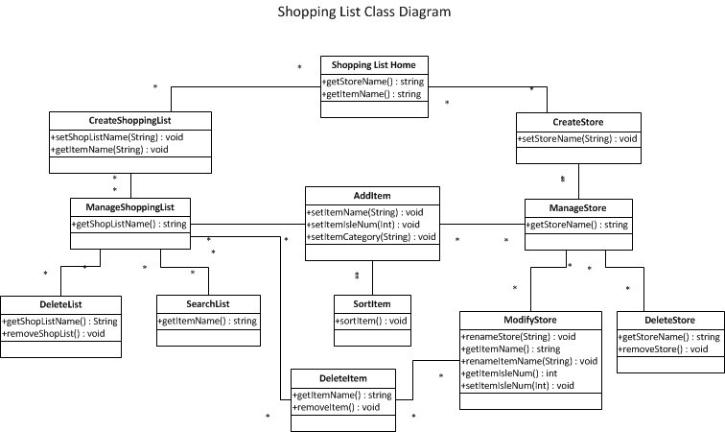

**Figure 3.0**

# 4.0. Data Structure Design

# The data storage

# 4.1. Scheme Diagram

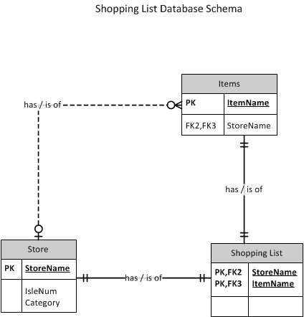

**Figure 4.0**